**Build in Functions**

1)Find the Ceil value of8.29

SELECT ceil(8.29) FROM dual;

2) Find the floor value of9.76

SELECT floor(8.29) FROM dual;

3) Find the square root of100

SELECT sqrt(100) FROM dual;

4) Demonstrate the use of least & greatest funs in astring

SELECT least(7,9,14,19,22) FROM dual;

SELECT greatest(7,9,14,19,22) FROM dual;

5) Display the systemtime

SELECT sysdate from dual;

6) . Use Select To_Char ( ) to display date and time in differentformats

SELECT TO_CHAR(SYSDATE,'DD/MM/YYYY') from dual;

7) Find the abs value of8.29

SELECT ABS(8.29) FROM dual;

8) . Create a table named angle

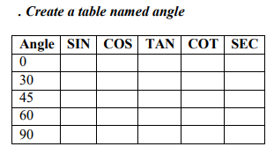

CREATE TABLE angle (angle int,sin decimal(4,2),cos decimal(4,2),tan decimal(4,2),cot decimal(4,2),sec decimal(4,2))

INSERT INTO angle(angle) values (0)

